# Testing

## Integration testing

* + Scenario: 1
  + Scenario: 2
  + Scenario: 3
  + Scenario: 4
  + Scenario: 5
  + Scenario: 6
  + Scenario: 7
  + Scenario: 8
  + Scenario: 9
  + Scenario: 10
  + Scenario: 11
  + Scenario: 12
  + Scenario: 13
  + Scenario: 14
  + Scenario: 15
  + Scenario: 16

## Test Case

## Integration testing:

### Scenario 1

**Task:** Create a new account

**Persona:** Bijay Giri

**User Group:** Non- registered customer

#### Scenario

Bijay is looking for some groceries for his house online and while searching for his groceries he comes across The Clechuderfax E-chain website. He’s an unregistered customer of

the website and he decides to make an account for buying the groceries.

### Steps:

* Bijay opens Clechuderfax website in his browser.
* Bijay clicks on **sign in** page.
* Bijay is an unregistered user, so he clicks on **create a customer account**.
* Bijay enters his details in the Registration form.
* Validation is shown for any mistakes made by Bijay while entering his details.
* After filling all the required fields correctly, Bijay accepts the terms and conditions.
* Bijay clicks on **register**.
* An email is sent to Bijay for verifying his account.
* Bijay logs into his Gmail account and clicks on the verification link.
* Bijay is now a verified customer.

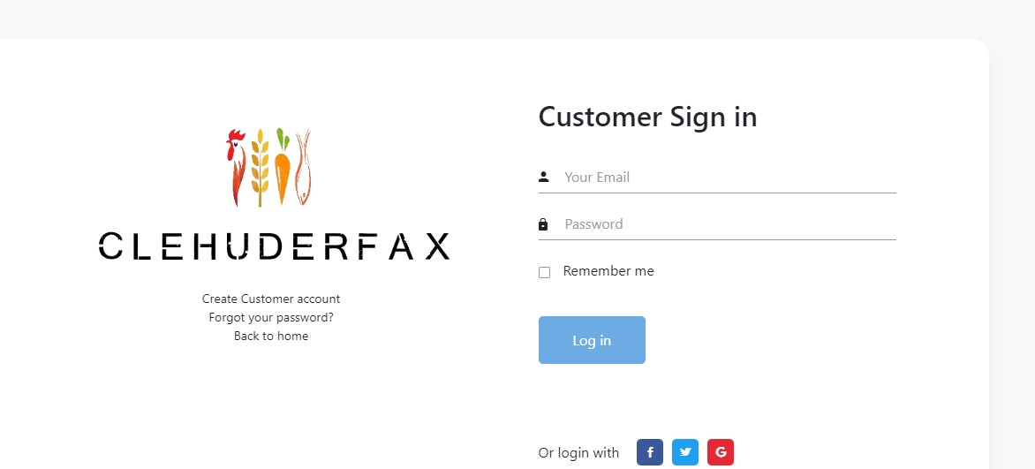

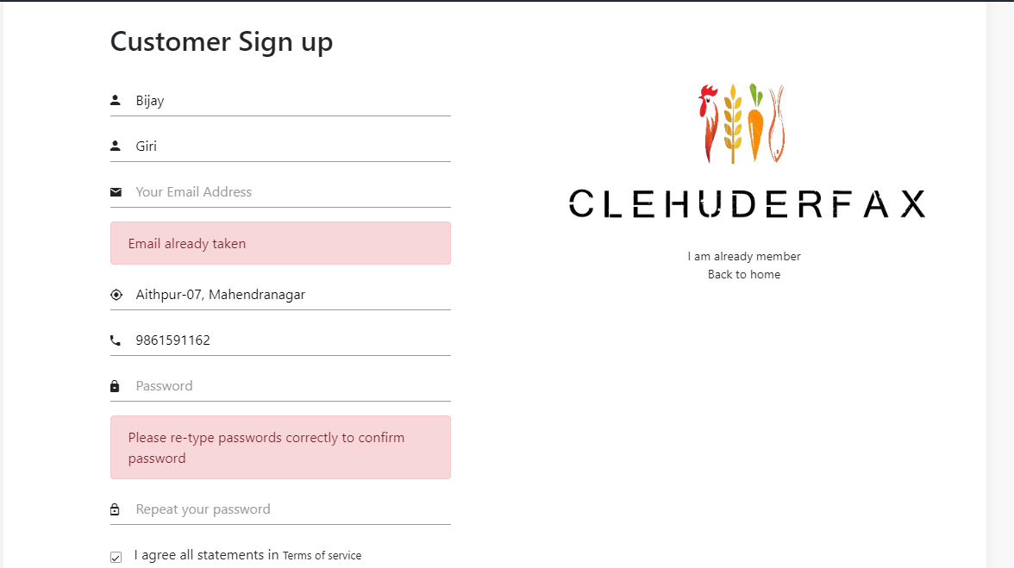

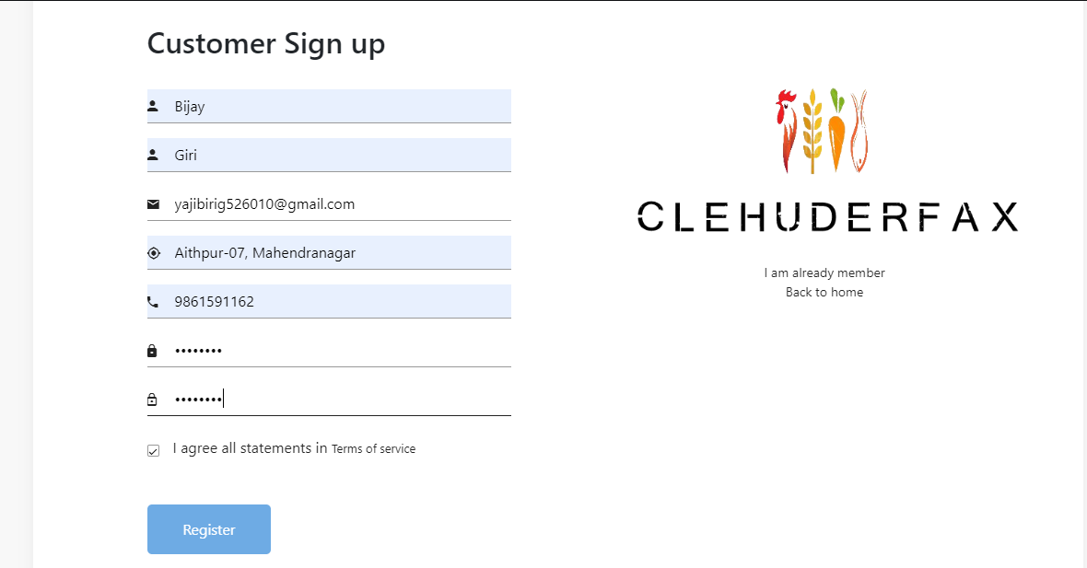

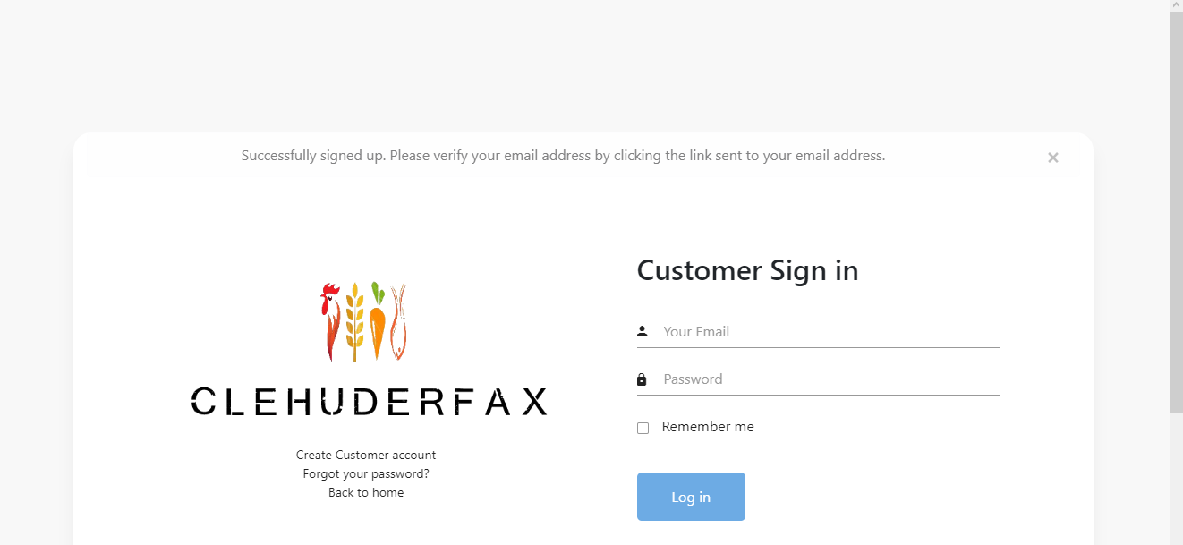

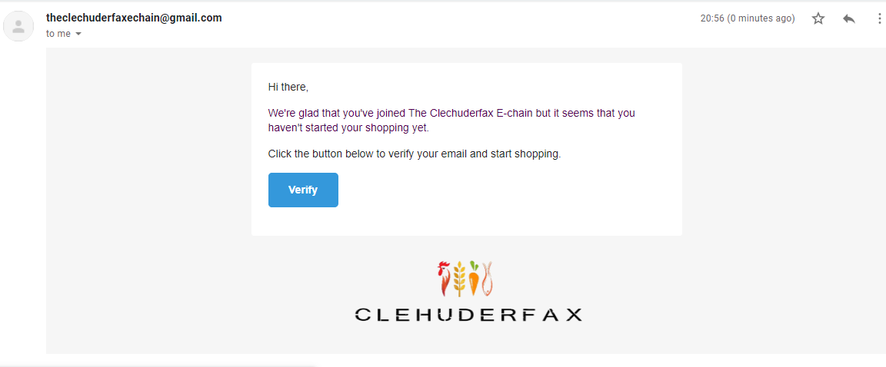

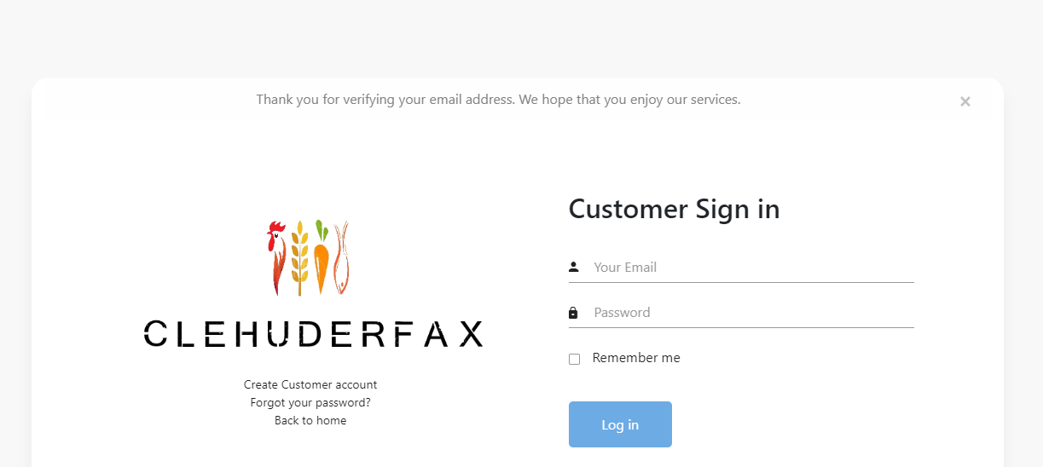

## Scenario 2

**Task:** Login to a registered account

**Persona:** Bijay Giri

**User Group:** Registered customer

#### Scenario

Bijay is verified registered customer and wants to login to Clechuderfax website

### Steps:

* Bijay opens Clechuderfax website in his browser.
* Bijay clicks on **Login**
* Bijay enters his details in the Login form.
* Instant validation for any mistakes made by Bijay while entering his details.
* Bijay re-enters his correct email and password.
* Bijay clicks **Login** button.
* Bijay is now logged in.

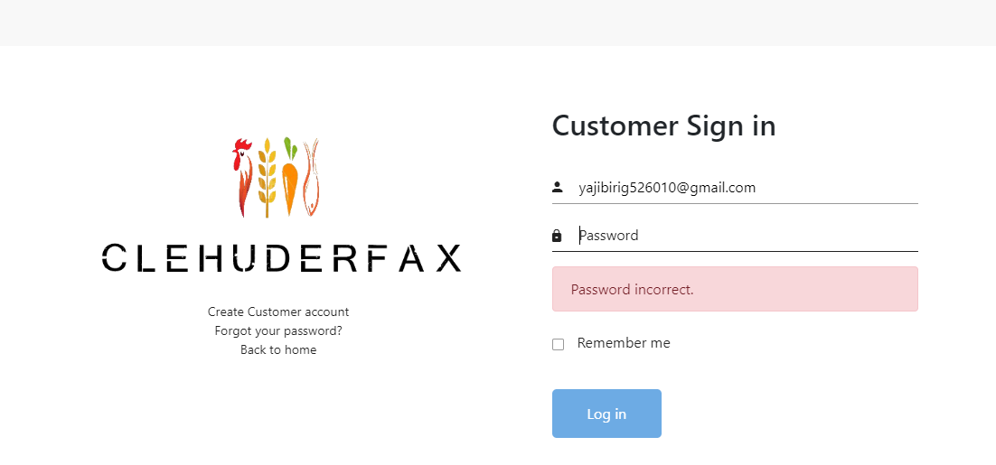

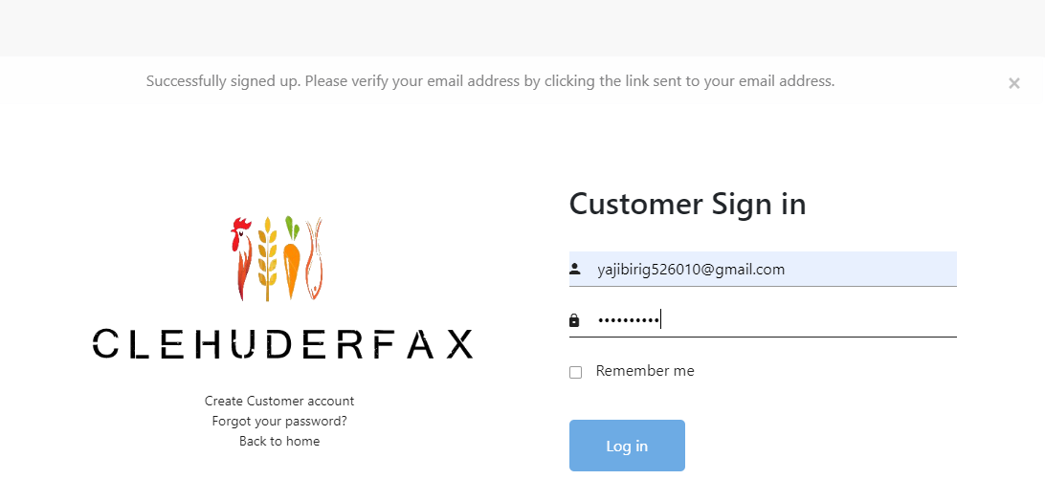

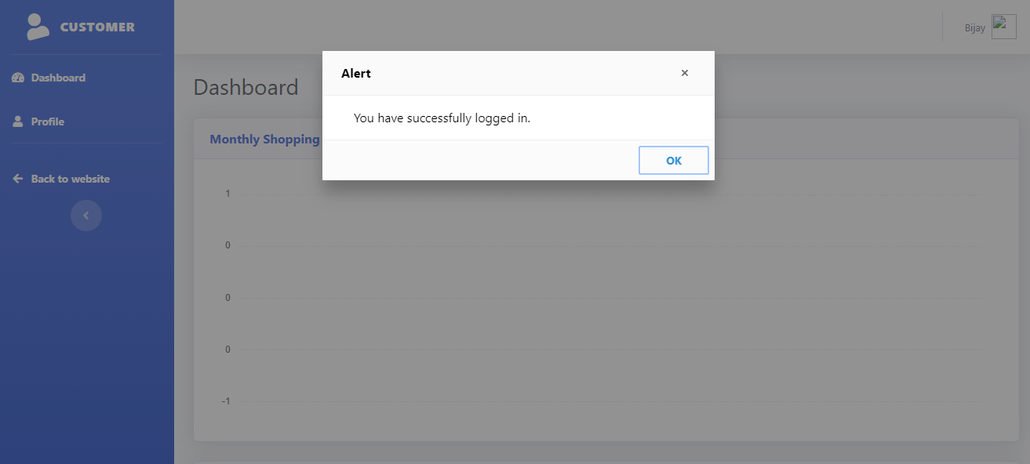

## Scenario 3

**Task:** Change profile picture and details

**Persona:** Bijay Giri

**User Group:** Registered customer

#### Scenario

Bijay is verified registered customer and wants to login to Clechuderfax website

### Steps:

* Bijay is now logged in and is redirected to his account.
* Bijay clicks on **profile**.
* Bijay wants to upload his profile picture.
* Bijay clicks on **choose file**.
* Bijay selects the photo he wants to upload as profile picture.
* Bijay clicks on **save changes**.
* Bijay clicks on back to website to continue shopping.



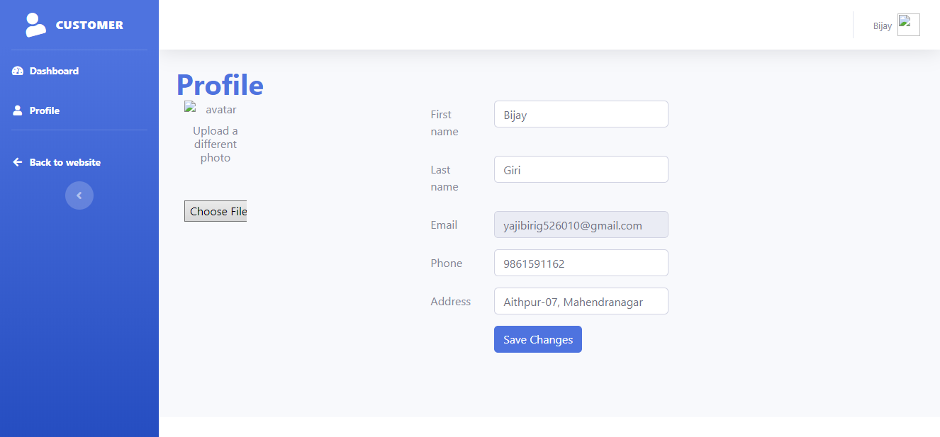

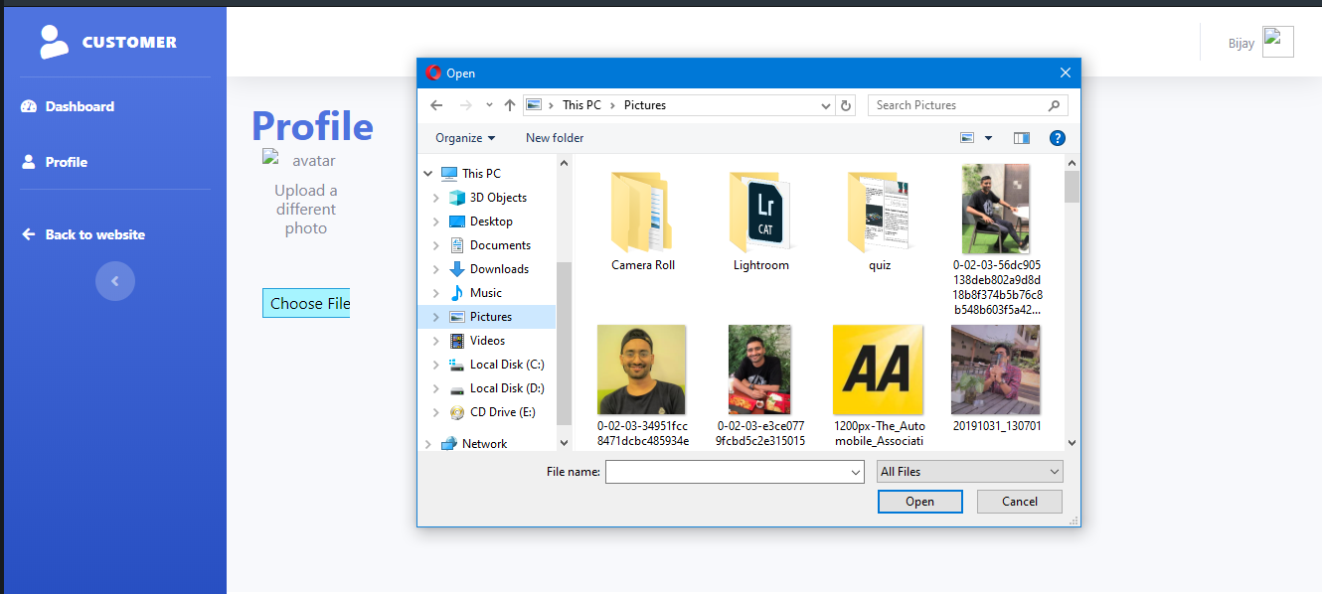

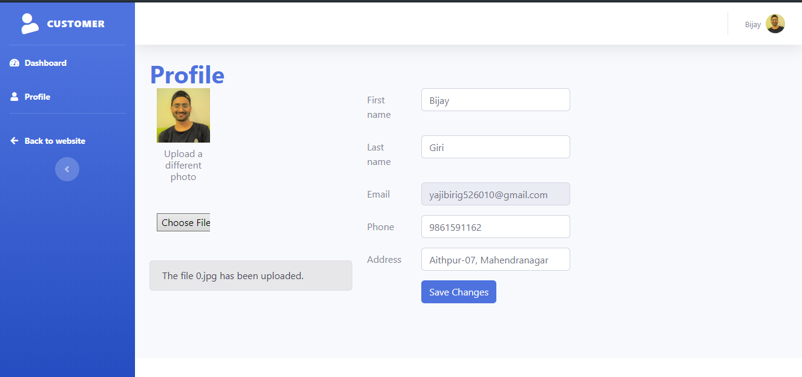

### Scenario 4

**Task:** Add Products to **Cart**

**Persona:** Non-registered user

**User Group:** non-registered customer

#### Scenario

Non-registered user wants to add a product to cart

### Steps:

* User clicks on add to cart/
* User is asked to login before adding product to page and is redirected to login page.

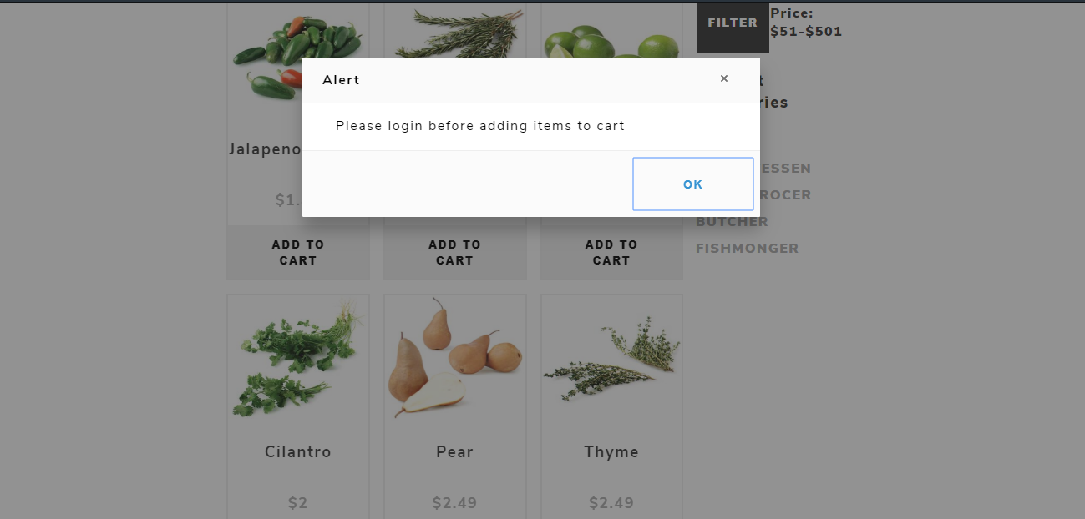

### Scenario 5

**Task:** Check-outfrom Cart

**Persona:** Bijay Giri

**User Group:** Not logged in Customer

#### Scenario

### Bijay is a not logged in customer and adds a product to his cart, so he is redirected to login page.

### Steps:

* Bijay opens Clechuderfax site in his browser
* Bijay selects the desired product of choice
* Bijay adds product to cart by clicking the add to cart button
* Bijay is redirected to the **login** page
* Bijay enters his details in the Logins
* Bijay clicks **login** button
* Bijay is now logged in
* Bijay can now successfully add product to his cart.
* Bijay can change number of quantities of product in his cart.
* Bijay clicks on **checkout** button.
* Bijay is redirected to checkout form.
* Bijay selects collection slot.
* Bijay clicks on Check out with PayPal.
* Bijay logins with his PayPal account.
* Bijay sees paid amount.
* A receipt of the bought product is sent to Bijay’s account.
* Bijay checks-out successfully

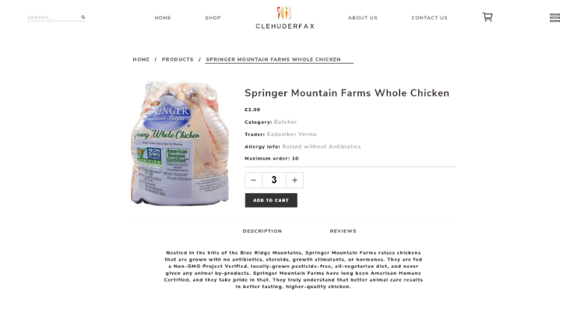

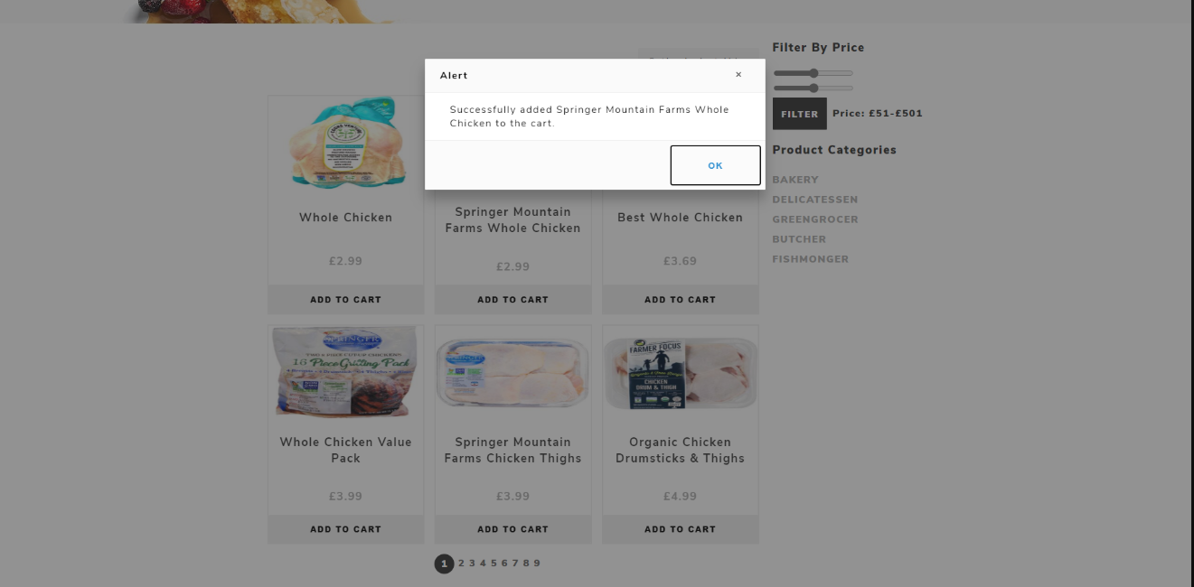

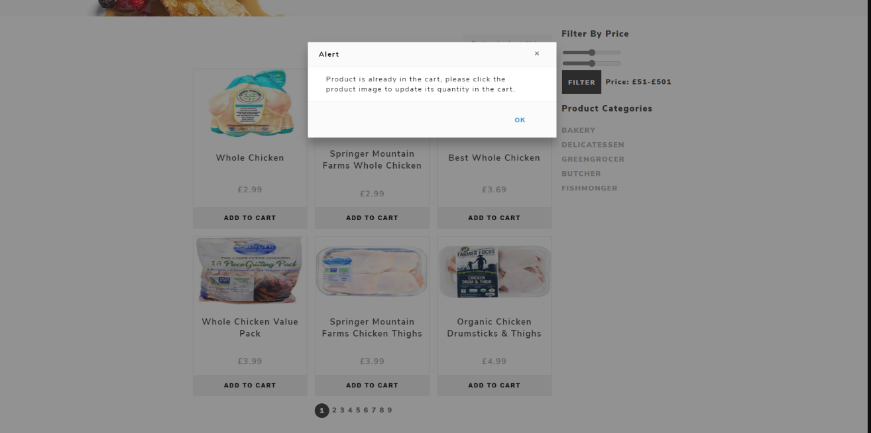

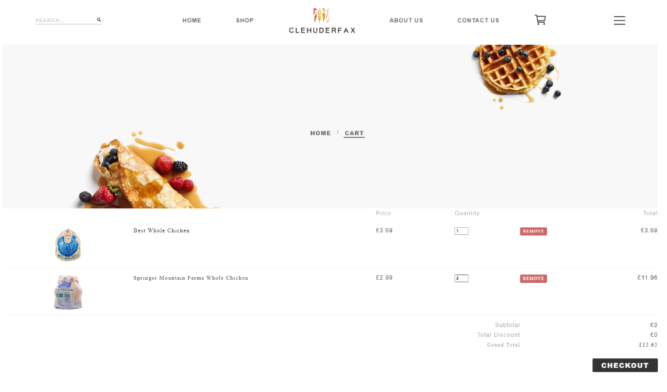

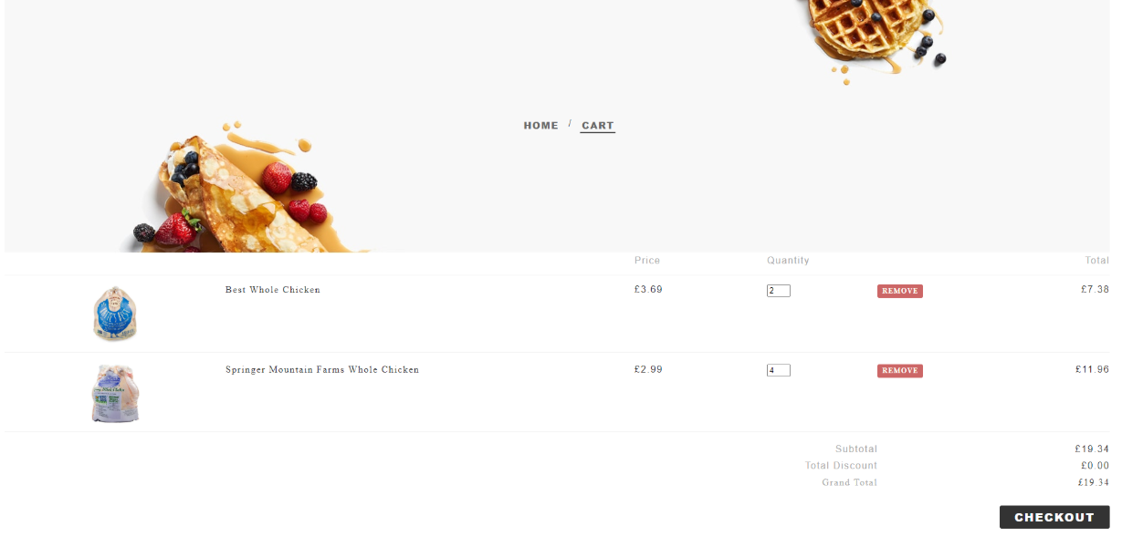

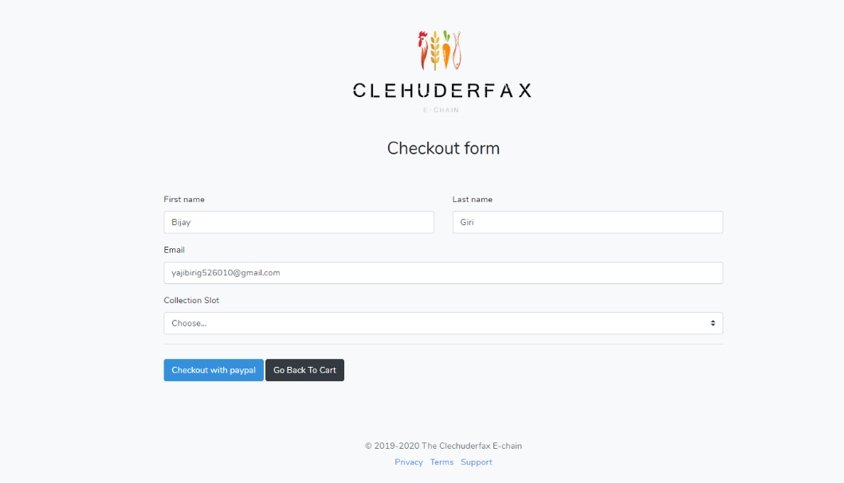

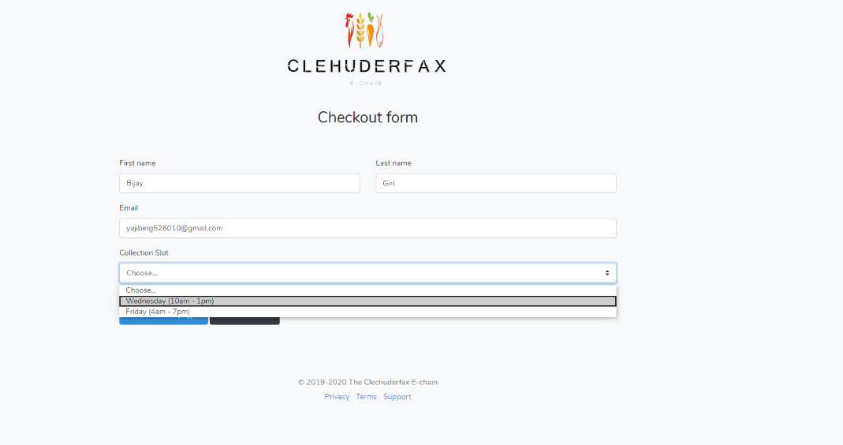

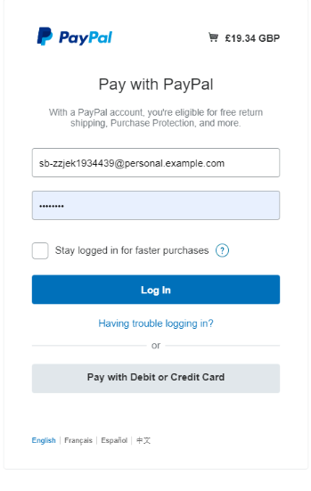

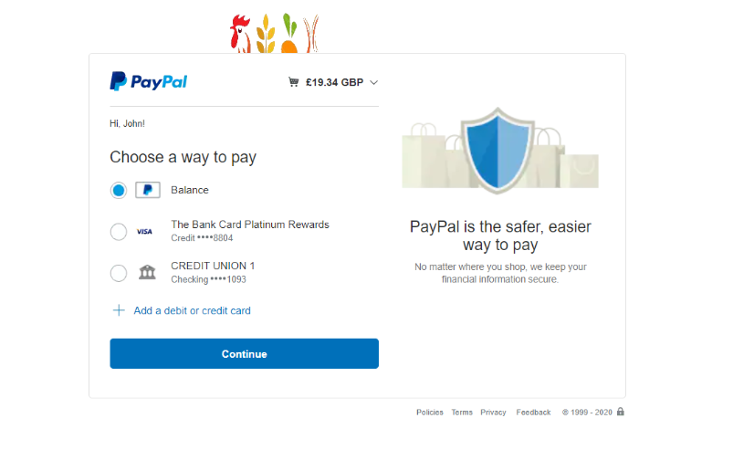

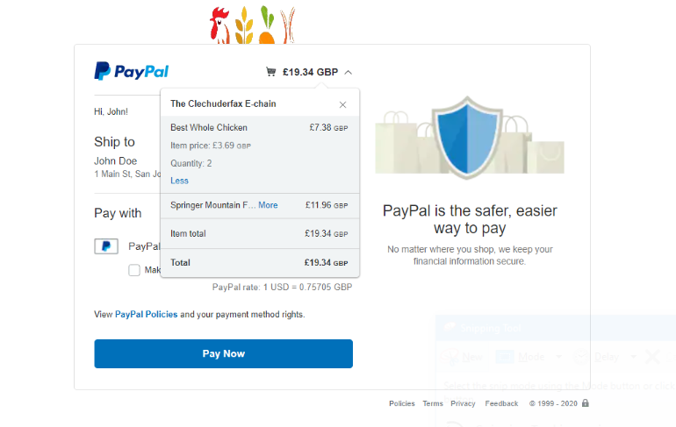

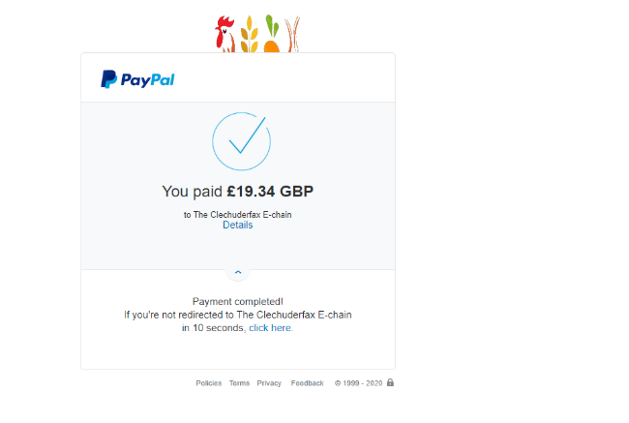

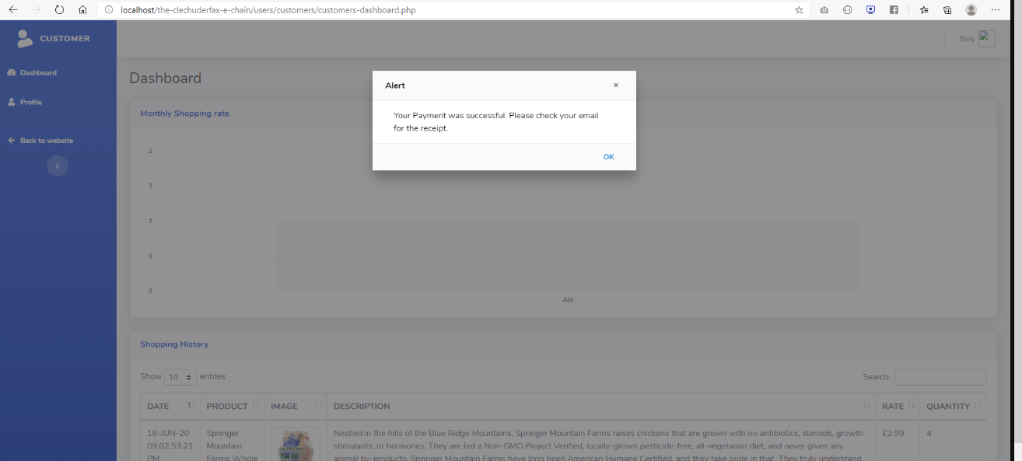

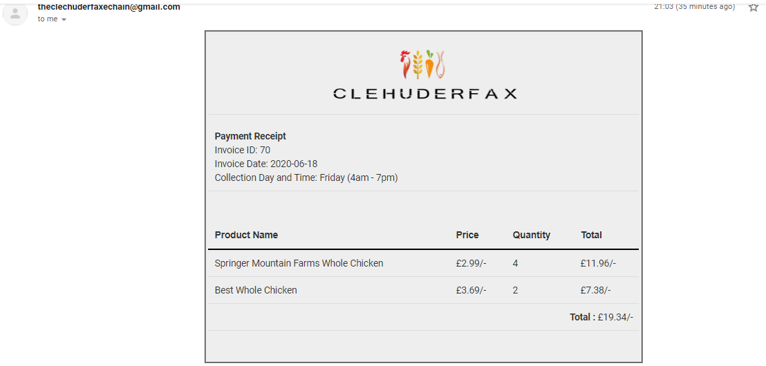

### Scenario 6

**Task:** Remove product(s) from cart

**Persona:** Bijay

**User Group:** Registered Customer

#### Scenario

### Bijay wants to remove products from the cart after added

### Steps:

* Bijay opens Clechuderfax site in his browser
* Bijay selects the desired product of choice
* Bijay clicks on **add to cart** button
* Bijay clicks on my cart
* Bijay clicks on the **remove** to delete from the cart

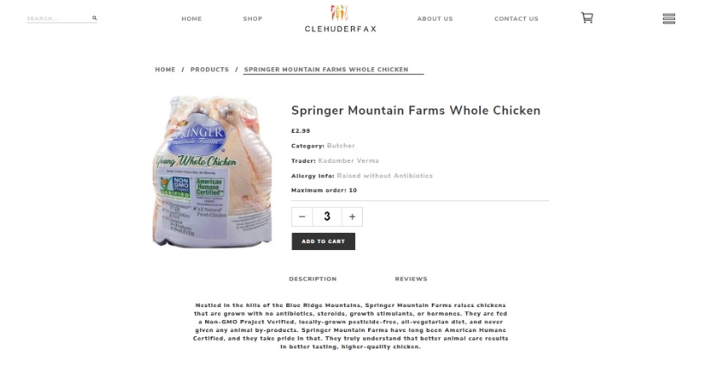

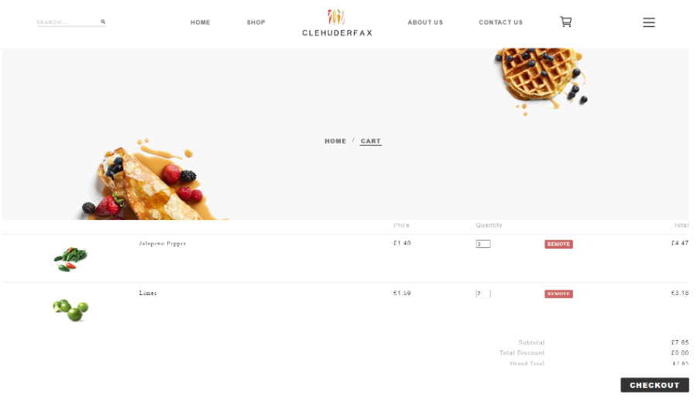

### Scenario 7

**Task:** Search for a product with particular keyword

**Persona:** Bijay

**User Group:** Registered Customer

#### Scenario 8

### Bijay is a registered user of Clechuderfax. He wants to buy some Jalapeno Pepper. He clicks on the search bar and types Jalapeno.

### Steps:

* Bijay opens the site in the browser
* Bijay clicks search box and writes key word
* Bijay clicks search icon

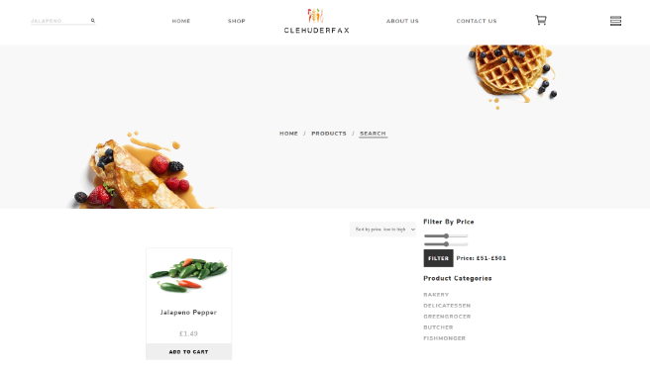

### Scenario 9

**Task:** Join as a new trader of Clechuderfax

**Persona:** Dipesh

**User Group:** Non- registered Trader

#### Scenario

Dipesh comes across the Clechuderfax site and he wants to sell his products in the site

### Steps:

* Dipesh opens site in browser
* Dipesh clicks on **trader sign up**
* Dipesh fills form.
* Dipesh clicks on **Register**
* Dipesh tries to login without verifying his account
* Dipesh is alerted to verify his account before logging in.
* Dipesh verifies his account and logs in using correct credentials.



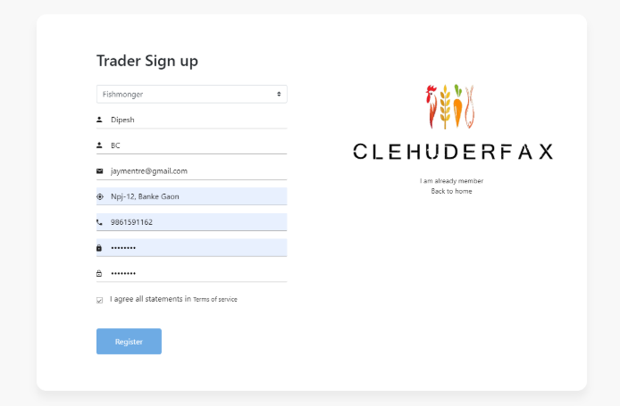

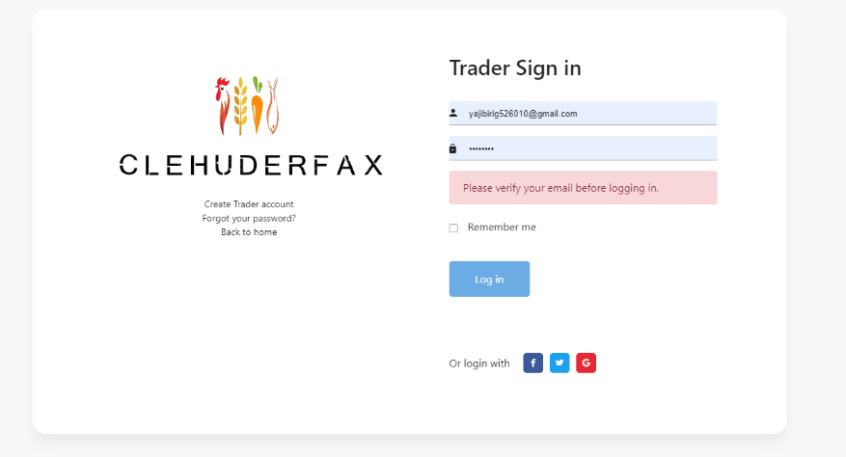

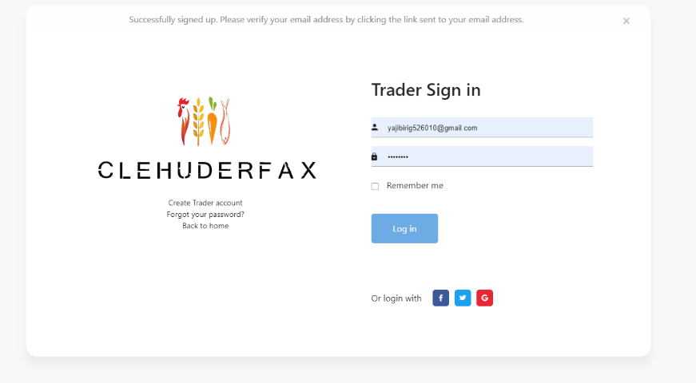

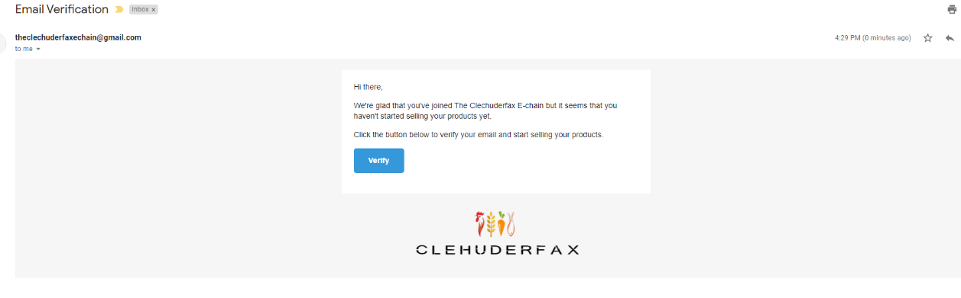

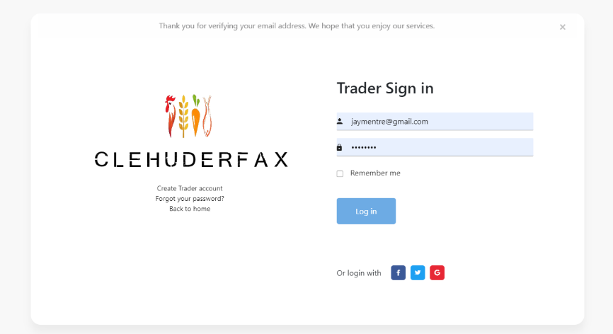

### Scenario 10

**Task:** Updating trader profile

**Persona:** Dipesh

**User Group:** Registered Trader

#### Scenario

### Dipesh wants to update his profile picture and info

### Steps:

* Dipesh logs into his profile.
* Dipesh clicks on **profile**
* Dipesh chooses profile picture and clicks on **save changes**.

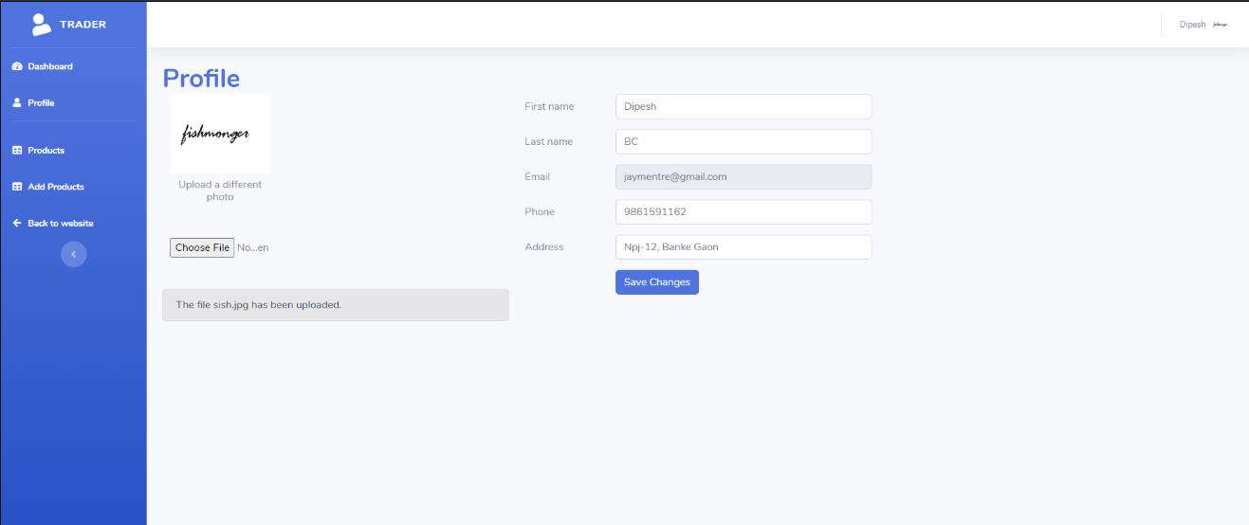

### Scenario 11

**Task:** Add Product

**Persona:** Dipesh

**User Group:** Registered Trader

#### Scenario

Dipesh wants to Add a product

### Steps:

* Dipesh logins to trader login.
* Dipesh clicks on **add product** from navigation menu.
* Dipesh fills all the necessary fields with Product image.
* Dipesh clicks on Add Product.

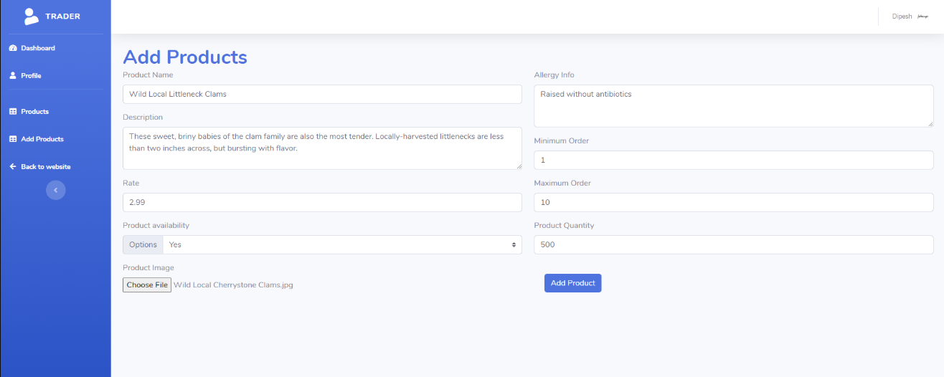

### Scenario 12

**Task:** Update and Delete Product

**Persona:** Dipesh

**User Group:** Registered Trader

#### Scenario

### Dipesh wants to update and delete product

### Steps:

* Dipesh logins to trader login.
* Dipesh clicks on **product** form navigation menu.
* Dipesh makes necessary modifications.
* Dipesh clicks on **update Product.**
* Dipesh wants to delete the added product.
* Dipesh clicks on the **delete** button next to a product.
* The product gets deleted.

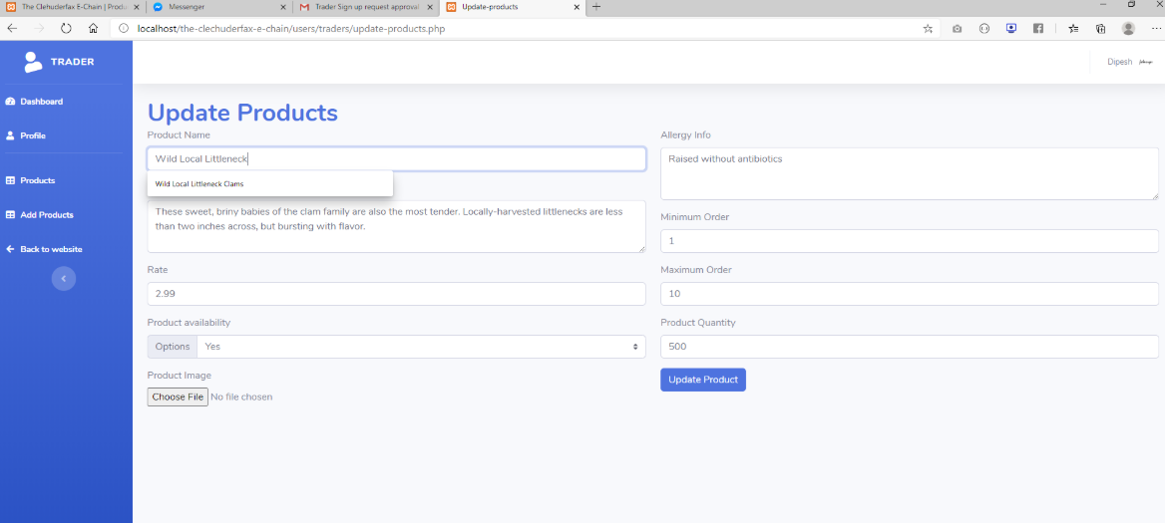

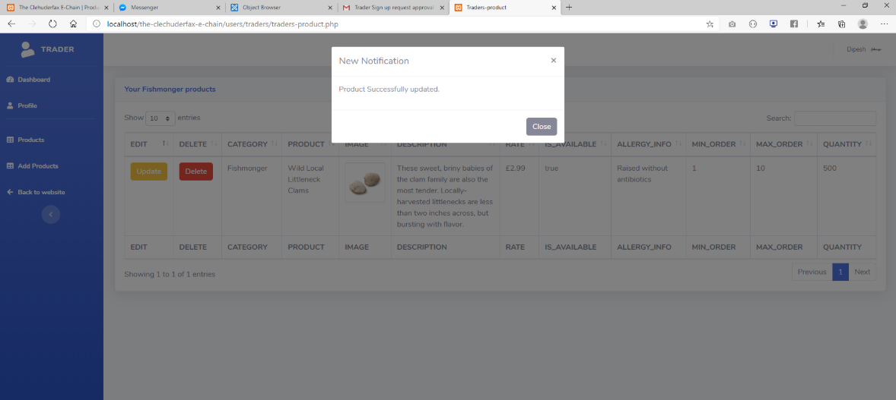

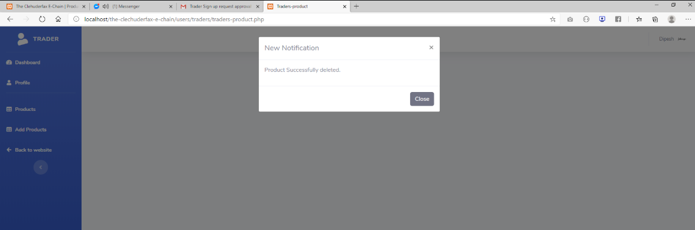

### Scenario 13

**Task:** Recover Password

**Persona:** Bijay

**User Group:** Registered Customer

### Scenario

Bijay wants to recover his password.

Steps:

* Bijay clicks to **forgot password.**
* Bijay enters his verified Email Address.
* Bijay gets an email with a link to reset his password.

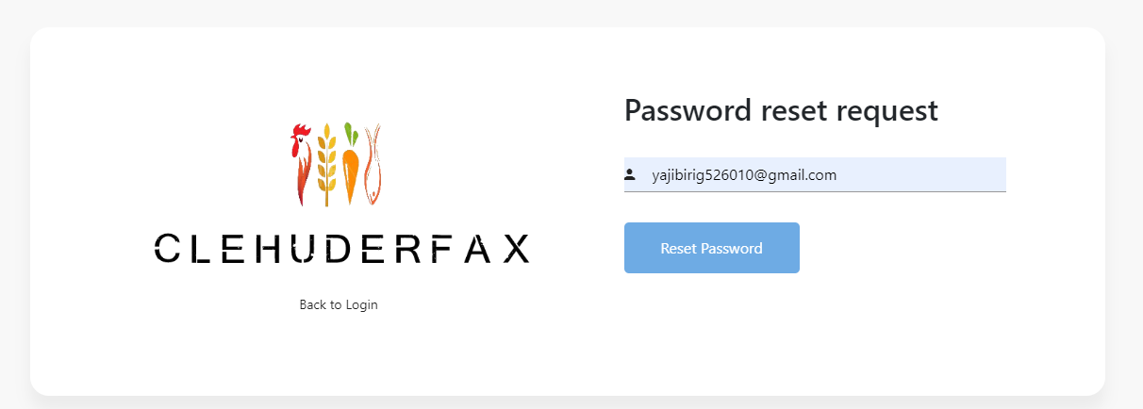

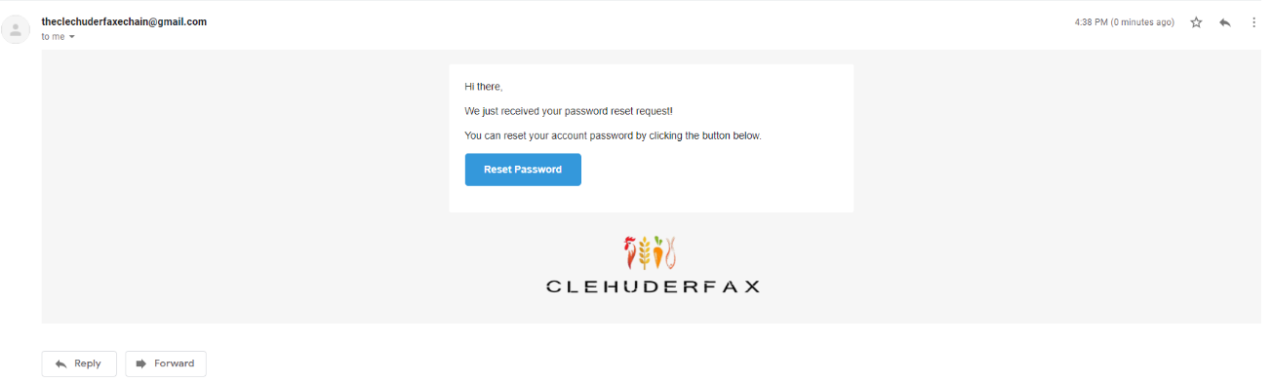

### Scenario 14

**Task:** Super Admin

**Persona:** Dipesh

**User Group:** Registered Admin

### Scenario

Dipesh wants to access the admin Dashboard.

Steps:

* Dipesh clicks on sign in.
* Dipesh enters his verified Email address and password
* Dipesh gets redirected to admin dashboard.

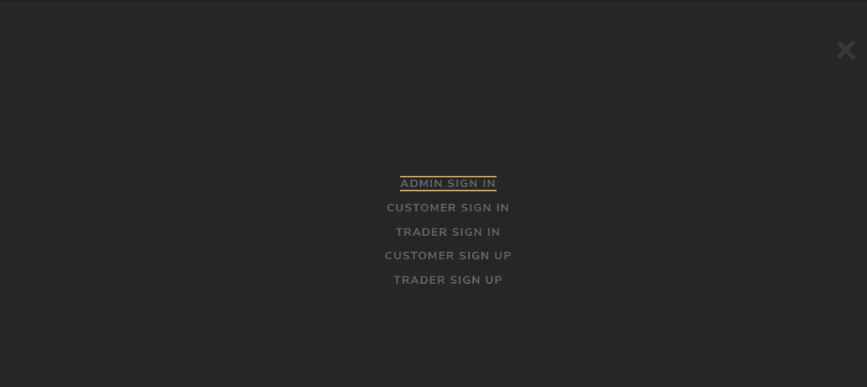 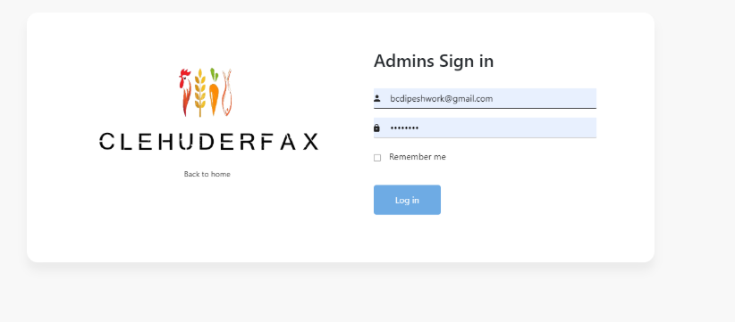

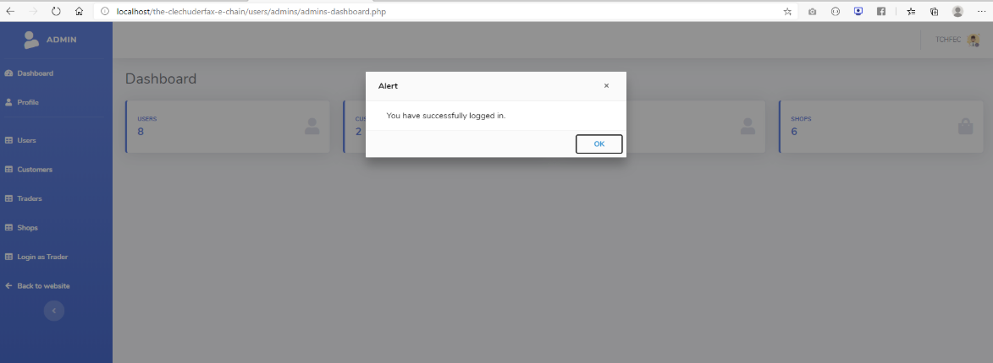

### Scenario 15

**Task:** Super Admin

**Persona:** Dipesh

**User Group:** Registered Admin

### Scenario

Dipesh wants to update and delete a user.

Steps:

* Dipesh signs into his account.
* Dipesh clicks on **users** from navigation menu.
* Dipesh clicks on the **update** button next to the user he wants to update.
* Dipesh makes required amendments.
* Dipesh clicks on **update user**.
* Dipesh wants to delete a user.
* Dipesh clicks on **delete** button next to the user that he wants to delete.
* Dipesh deletes the user.

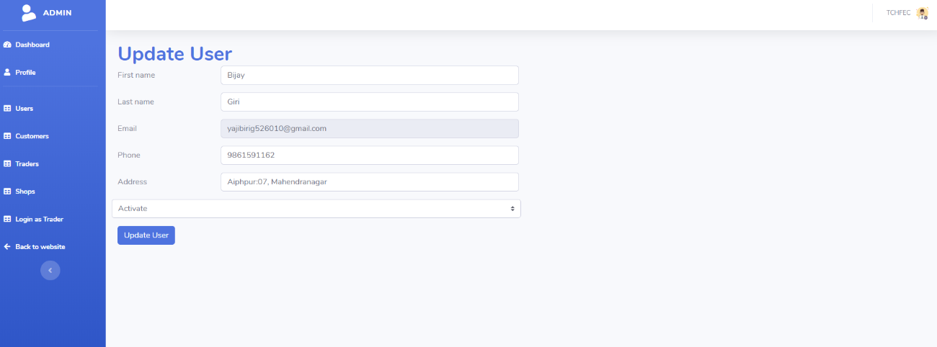

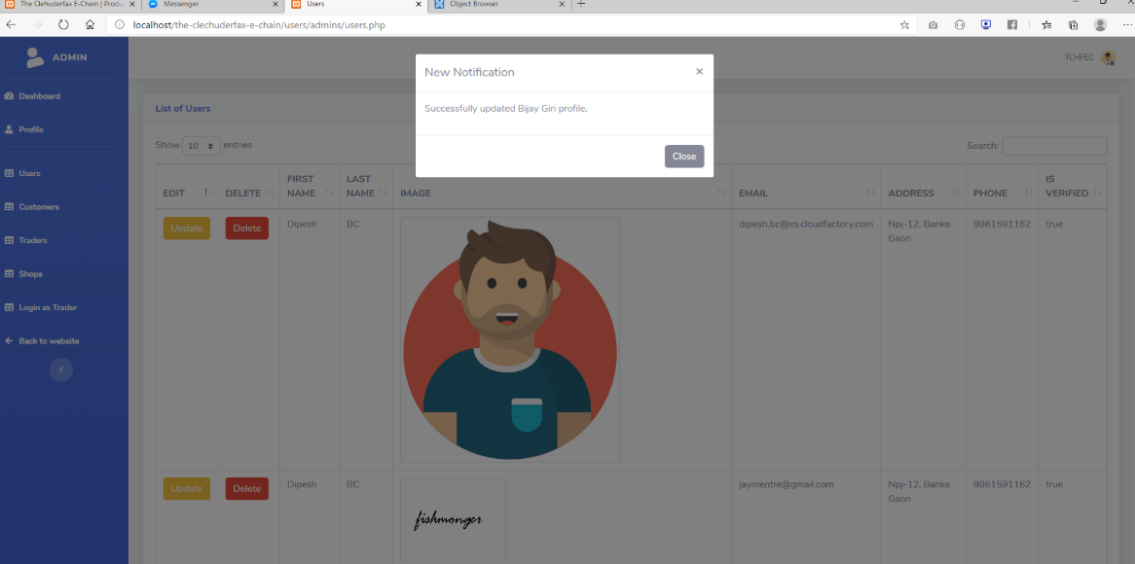

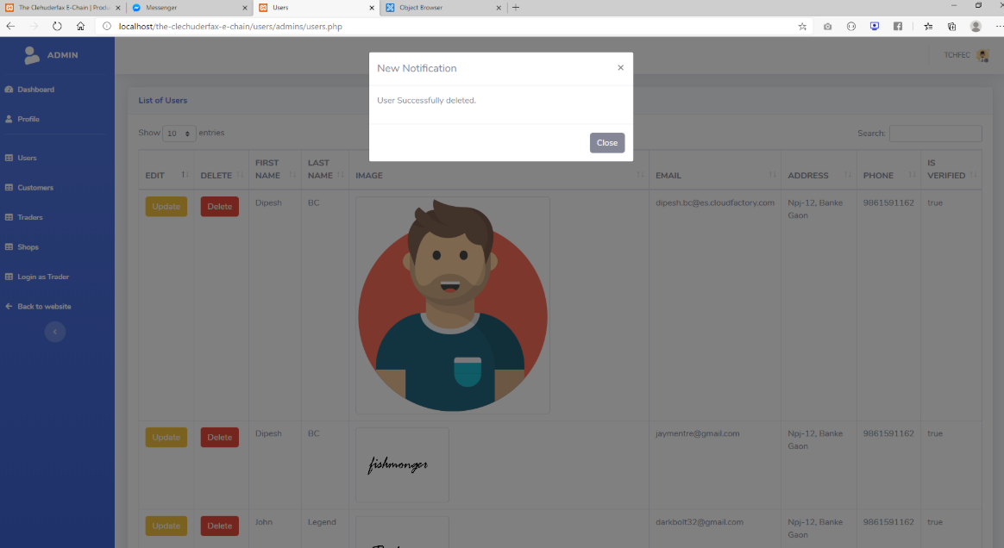

### Scenario 16

**Task:** Super Admin

**Persona:** Dipesh

**User Group:** Registered Admin

### Scenario

Dipesh wants to update and Delete a shop

Steps:

* Dipesh signs into his account.
* Dipesh clicks on **shops** from navigation menu.
* Dipesh clicks on the **update** button next to the shop he wants to update.
* Dipesh makes required amendments.
* Dipesh clicks on **update Shop**.
* Dipesh wants to delete a shop.
* Dipesh clicks on **delete** button next to the shop that he wants to delete.
* Dipesh deletes the shop.

